Israel-Palestine Learning Tour

Dates: 12-23 October, 2023, future dates in 2024 TBA – respond with interest at lappjost@gmail.com

Price: $900, airfare not included. All lodging, food, transport costs covered in country.
Tentative itinerary

Nazareth: 3 days: arrival in Jerusalem. Charter a private bus to take us to Nazareth from the airport. On arrival in Nazareth, start off with evening rest or possibly a short walk to the Basilica and tour of the old city. In the next three days of touring, likely sites include the Nazareth Village, Hospital, and Nursing School, the Jesus Trail, Basilica of the Annunciation, Church of the Adolescence, and the beautiful churches and the probable site of the Sermon on the Mount around the Sea of Galilee. Some activities might include a tour from our former supervisors at the Nazareth Project, visiting with Messianic Jews and Arab Christians who work at the Nazareth Village, and hearing from local Arab Christian leaders about the local Christian community.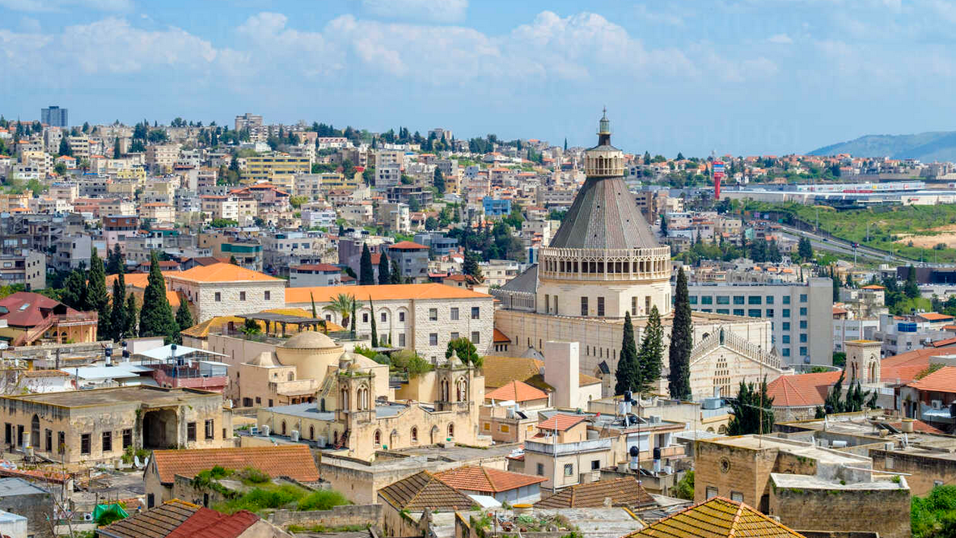
A view of Nazareth

Bethlehem and Hebron, 4 days: take the bus into Bethlehem and get off at Bethlehem Bible College. Likely sites include Bethlehem Bible College, the Arab Women´s Union, the Walled Off Hotel, the Wall itself, Wi´am Peace Center, Church of the Nativity and Manger Square, and Tent of Nations. We´ll learn about Bethlehem Bible College´s solar project and meet with COMET ME – an Israeli organization that puts solar panels on the homes of Palestinians who the Israeli authorities cut off from the grid. We will also do a day trip to Hebron, experiencing a CPT-arranged tour of Hebron, visiting a hot glass factory and a keffiyeh factory in Hebron, and visiting the school where David´s great aunts worked for 37.5 years with MCC.

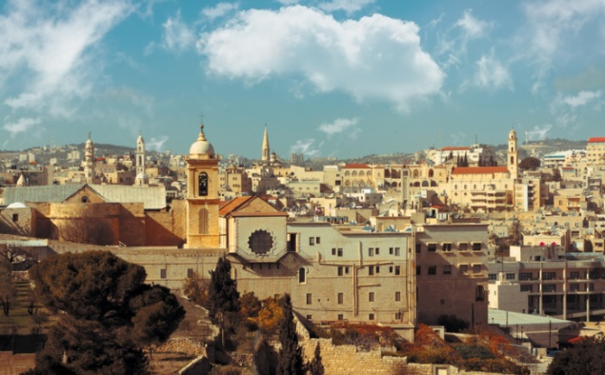
A view of Bethlehem
Jerusalem, 3 days: Again charter a bus into Jerusalem and stay in the center of the Old City. Likely sites include the ancient markets, the Wailing Wall, the Sunbula Cooperative, the Austrian Hostel, Yad Vashem Holocaust Museum, Damascus Gate, a tour with the Israeli Committee Against Housing Demolitions, and the Lutheran Church. We will have ample time to take in the Old City in the evenings, find restaurants and cafés, and shop at Arabic markets.

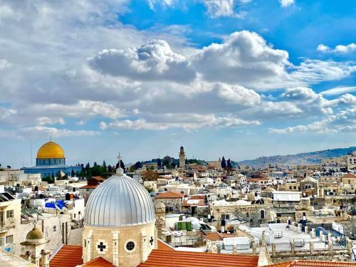
Jerusalem

Register Interest at lappjost@gmail.com

